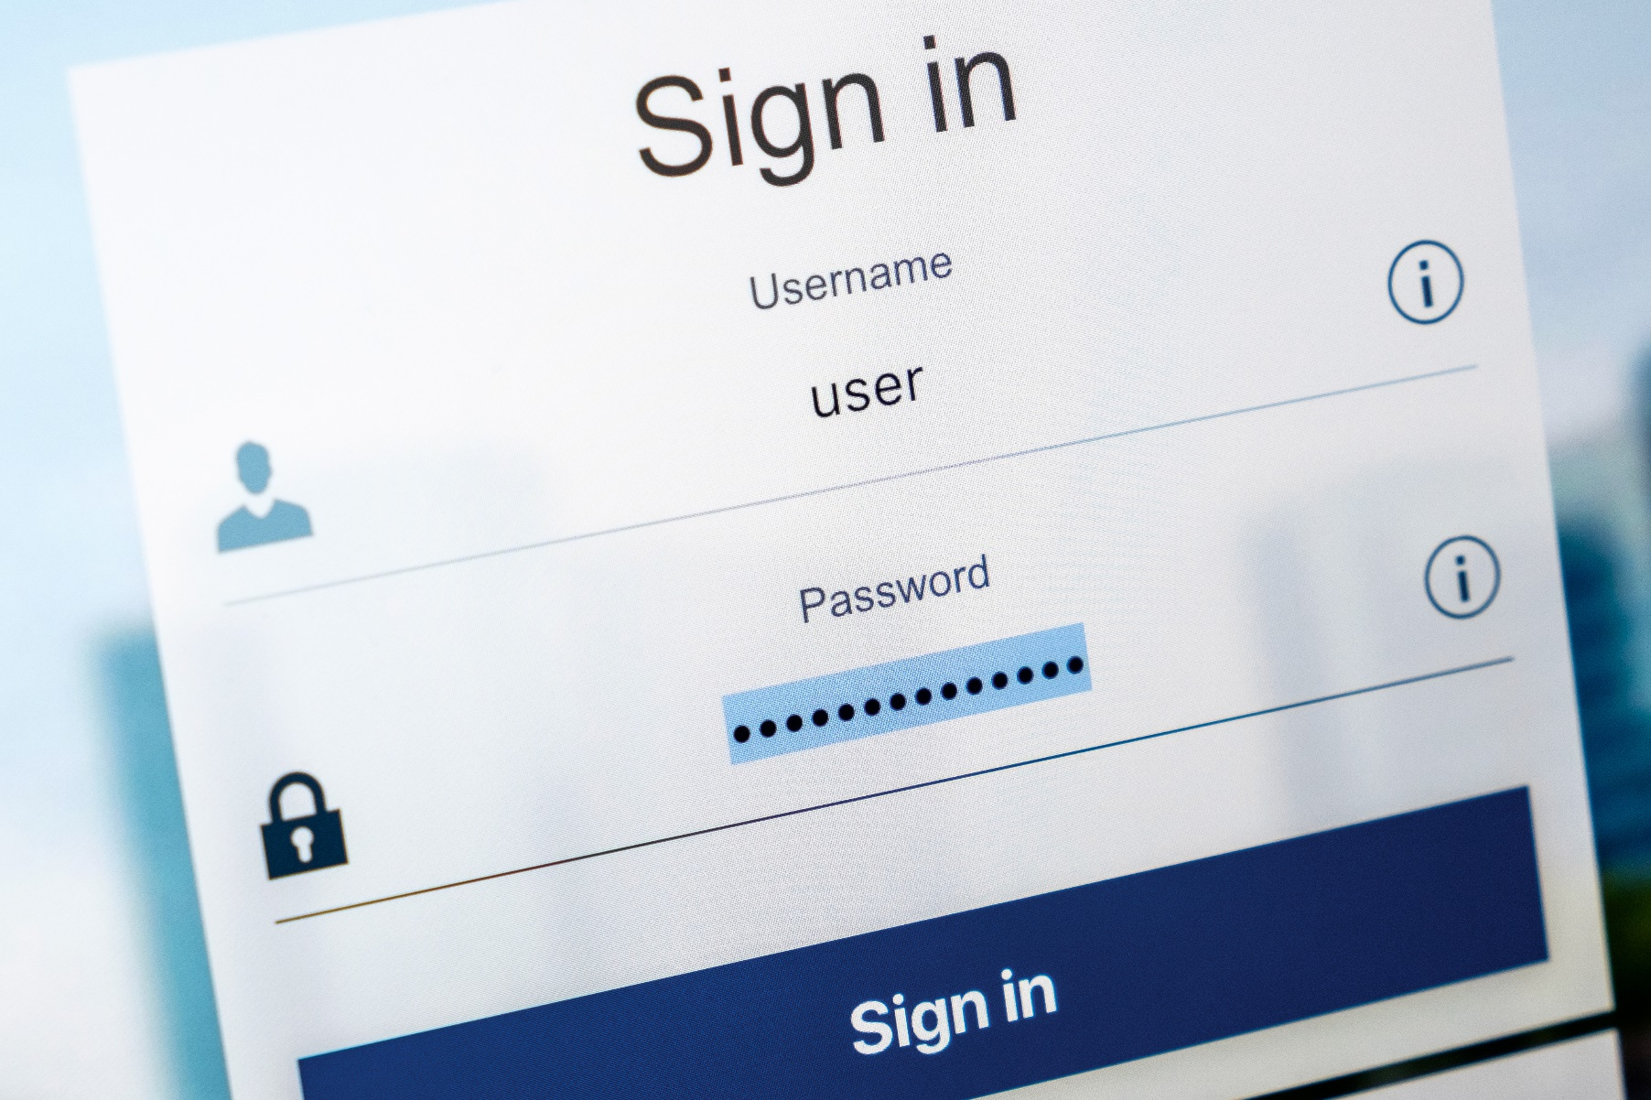

Cyber Incident Response Plan
<organisation name>

Contact the Victorian Government Cyber Incident Response Service for assistance in responding to cyber incidents. Contact 1300 CSU VIC or cybersecurity@dpc.vic.gov.au

Cyber Incident Response Plan
Sole Trader Michael Mountjoy
Contents
1. Introduction 3
1.1 Context 3
1.2 Purpose 3
1.3 Authority 3
1.4 Review 3
2. Terminology and Definitions 4
3. Common Cyber Incidents and Responses 5
3.1 Potential Threat Vectors 5
4. Roles and Responsibilities 6
4.1 Incident Management Team 6
5. Incident Response Process 8
Step 1: Detection and Analysis 8
Step 2: Containment and Eradication 11
Step 3: Communications and Engagement 14
Step 4: Recover 15
Step 5: Learn and Improve 15
Appendix A. Situation update (template) 17
Appendix B. Incident Log (template) 18
Appendix C. Resolution action plan (template) 19
Appendix D. Evidence register (template) 20
Appendix E. Assets and key contacts (template) [update as appropriate] 21

IMPORTANT
Before activating this cyber incident response plan it is important that you update the document to include information specific to your organisation and its cyber security operating environment.
Populate the document with details of key contacts, incident management team members, critical assets, organisational policies/procedures and other security-related information.
REMOVE THIS TEXT BOX BEFORE FINALISING THE PLAN

Introduction

  - Context
A simulated ransomware attack was launched on a Windows 10 VM endpoint. Windows Event Viewer will collect log telemetry about how the attack happened in order to understand what may have went wrong in the endpoint’s network security. Sysmon will enhance this log collection, ensuring more granular analysis of the actions from the attacker.
This ransomware project will be stored in a Github Repository, under the name of inevitable-debug. Within this repository, there will be an installation folder that details the step-by-step process on how to install and configure Infection Monkey, the simulated ransomware attack agent.
Detailed log analysis will also be performed, examining some of the most significant logs from a captured spread of 89 logs from the incident. These logs will show how the attacker was able to develop resources, perform reconnaissance, execute command prompt statements, and the impact it had on sensitive data. Some of these actions captured by the log telemetry will also be mapped to the Mitre ATT&CK Framework.
This document supports Sole Trader Michael Mountjoy in managing contemporary cyber threats and incidents. The application of this document will support Sole Trader Michael Mountjoy in reducing the scope, impact and severity of cyber incidents.

Purpose
This document describes the process that is required to ensure an organised approach to managing cyber incidents within Sole Trader Michael Mountjoy and coordinating response and resolution efforts to prevent or limit damage that maybe caused.
This document is developed using the National Institution of Standards and Technology (NIST) Computer Security Incident Handling Guide.

Authority
This cyber incident response plan is managed by Michael Mountjoy. This plan has been endorsed by Michael Mountjoy who is responsible for ensuring that Sole Trader Michael Mountjoy has a dependable and secure ICT environment.

  - Review
This incident response plan will be reviewed annually by Michael Mountjoy, or following any cyber incident as deemed necessary by Sole Trader Michael Mountjoy.

Terminology and Definitions
This section outlines key terminology and definitions used in this plan.

What is a cyber event?
A cyber event has the potential to become, but is not confirmed to be, a cyber incident.
Examples of cyber events include (but are not limited):
- Multiple failed sequential logons for a user
- A user has disabled the antivirus on their computer
- A user has deleted or modified system files
- A user restarted a server
- Unauthorised access to a server or system.

What is a cyber incident?
A cyber incident occurs when there is a breach of explicit or implied digital security policy that requires corrective action because it threatens the confidentiality, availability and integrity of an information system or the information the system processes, stores or transmits.
Examples of cyber incidents include (but are not limited to):
- Denial of service attacks (DoS) that affect system or service availability
- Virus or malware outbreak (including ransomware)
- Compromise or disclosure of sensitive or personal information
- Compromise of network credentials or an email account.
This plan identifies four categories of cyber incidents which are differentiated by the level of impact they create.

What is a ransomware attack?
A ransomware attack refers to malware that encrypts, damages, destroys or hides access to sensitive information unless some form of compensation is paid for it.
Examples of ransomware attacks include (but are not limited):
- CryptoLocker (2013): a phishing virus that encrypted sensitive data and demanded ransom in Bitcoin
- WannaCry (2017): a self-propagating worm that leveraged the Eternalblue exploit in Windows
- Colonial Pipeline (2021): Exfiltration of data and demanded ransom in Bitcoin to not release it

Common Cyber Incidents and Responses
The following table provides a list of common cyber incident types, along with the corresponding response activities (which form the typical minimum response).

# | Type / Description | Initial response to minimise potential harm
1 | Ransomware; a tool used to encrypt or lock victims’ data until a ransom is paid. | Immediately remove the infected device(s) from the network to limit the spread of ransomware. Capture all available logs relevant to the device. Isolate the devices while containment and eradication activities are determined.
2 | Malware Infections; a virus, worm, Trojan horse, or other code-based malicious entity that successfully infects a host. | Immediately remove the infected device(s) from the network to limit the spread of malware. Capture all available logs relevant to the device. Isolate the devices while containment activities are confirmed and eradication efforts are determined.
3 | Denial of Service (DoS) and Distributed Denial of Service (DDoS) attacks; overwhelming an ICT network with traffic that it cannot process, sometimes causing the network to fail. | Request gateway services provider to identify DOS/DDOS nature, attack vector and implement suitable solutions. Liaise with gateway services and network team to apply filters at network edge and / or increase capacity.
4 | Phishing and Social Engineering; deceptive communications designed to elicit users’ sensitive information (including network credentials). | Review logs of affected users (web and email logs) to determine whether malicious links/attachments were accessed. Consult users to confirm what actions they took, and whether any personal/sensitive information was provided in response to a phishing/social engineering attempt. Consider resetting user passwords and monitoring accounts for any unauthorised access.
5 | Data breach; unauthorised access to sensitive or personally identifiable information. | Contain the data loss/spill as soon as possible. Alert privacy, legal and communications/media teams. Investigate the cause of the data loss/spill.

Potential Threat Vectors
There are multiple vectors through which a cyber incident can arise. Maintaining awareness of these threat vectors will support Sole Trader Michael Mountjoy in identifying potential ‘weak spots’ or commonly targeted aspects of your network and systems. Some of the more common vectors include:

# | Type | Description
1 | External/removable media | An attack executed from a USB containing malware.
2 | Attrition | A DDoS attack on a critical network or system.
3 | Web | The redirection of web traffic to a malicious URL that installs malware on a victim’s device.
4 | Email | Phishing attacks that attempt to steal information and/or deploy malware to a victim’s device.
5 | Impersonation usage | For example, a domain that is created to imitate yours in an attempt to deceive victims (typically associated with phishing attacks).
6 | Improper usage | Human error resulting in a breach of information security policy; or attack from a malicious insider resulting in a cyber security incident.

Roles and Responsibilities
The following section details the composition and functions of the Sole Trader Michael Mountjoy Incident Management Team (IMT) and the Senior Executive Management Team (SEMT).

Incident Management Team
The Sole Trader Michael Mountjoy IMT is responsible for managing responses to cyber incidents. The members of the Sole Trader Michael Mountjoy IMT are identified below.

Name | Contact Details | Title | IMT Role
Michael Mountjoy | michaelevent3112@gmail.com | IT security manager | Incident manager  - Planning and operations  - Intelligence and analysis  - Technical advice
Akamai | support@akamai.com | Technical Support for Infection Monkey | - System/application support
Victorian Government Cyber Incident Response Service | 1300 CSU VIC (24/7) cybersecurity@dpc.vic.gov.au | Incident response and coordination services; Emergency Management | - Technical/forensic investigations and communications support
AusCERT – cyber technical advisory services | 1800 723 009 (24/7) vicsoc@auscert.org.au | Incident analysis, containment, eradication and recovery advice | - Technical investigations and support
*denotes an optional IMT position that may be activated only if required, based on the circumstances of an incident.

Incident Response Process
For assistance responding to cyber incidents contact the Victorian Government Cyber Incident Response Service on 1300 CSU VIC (24/7) or cybersecurity@dpc.vic.gov.au (business hours).

Quick Reference Checklist of Incident Response Actions

# | Activity
1 | Conduct analysis to determine whether an incident has occurred / or is occurring
2 | Determine the scope, impact and severity of the incident; categorise the incident
3 | Activate your IMT (and SEMT, if appropriate) to manage the response effort; begin documenting the situation
4 | Develop and implement a resolution action plan detailing containment, eradication and recovery activities; gather and record evidence
5 | Identity affected stakeholders – who will be impacted by the incident?
6 | Develop a notifications strategy and communicate key messages with affected stakeholders
7 | Confirm the threat has been eradicated and return affected systems/services to normal function (test systems/services to confirm expected functionality)
8 | Stand down your IMT/SEMT (when authorised by appropriate delegate); determine any stakeholder communications requirements
9 | Conduct a post incident review to identify things that worked well and any opportunities for improvement; document your learnings/insights
10 | Update your incident response plan to include any key learnings/insights

Step 1: Detection and Analysis

Incident Detection
The simulated ransomware attack was first detected when the end user on the Windows 10 VM noticed Banking Details.txt had the m0nk3y file extension added onto it. Upon opening the file, the sensitive contents of this file were jarbled. There was also a ransomware note that was left in the same directory specifying it was a simulated ransomware attack and there is no need to worry.

Windows Event Viewer did not flag any critical or warning events. In the Sysmon category in Event Viewer, it simply provided logs with the information tag specifying a few steps the simulated ransomware attacker took in their exploitation of the Windows 10 endpoint.

There was no intrusion detection system that was installed onto the Windows 10 VM. Only Microsoft Defender was enabled to potentially identify any malicious software behaviour.

Incident Analysis
Due to the Incident Detection phase, it is confirmed that the simulated ransomware attack was successfully performed. To reverse the ransomware attack, all that would need to be done is removing the m0nk3y file extension and re-running the tool on the sensitive Banking Details.txt file.

Viewing Windows Event Logs can be overwhelming due to the sheer amount of collected telemetry. Filtering for executions of the Infection Monkey.exe file isolated the logs that were relevant to the simulated ransomware attack. A customized XML query was created to reflect this. This involved mapping the ‘Image’ attribute to a value of the directory of the monkey island exe, and the ‘CurrentDirectory’ attribute to where the exe was stored. This is particularly useful if a log is referencing a parent directory when performing a command line prompt command, as it might not be directly running the image.

An effective standard operating procedure (SOP) for a similar attack of this nature would be to watch closely for resource development in any temp folders on the endpoint machine and suspicious outbound connections. Hardening network security by installing a Next Generation Advanced Firewall and performing security checks on inbound or outbound traffic would also help in preventing cyber incidents.

Incident Classification
The incident classification of this incident is simply a cyber incident. This is because security controls were successfully compromised to not only gain access to sensitive data but to encrypt them without any established security protocols to prevent or stop it from happening. It compromised personal information and could seriously affect the finances of the individual on that endpoint.

Step 2: Containment and Eradication

Resolution Action Plan
Although this was a simulated ransomware attack and was done in a safe environment, a real ransomware attack could still happen.

In this case, immediately disconnect the endpoint from the internet. This ensures the attacker would not be able to remotely execute code or perform further malicious actions on the endpoint. Any existing rootkits, malware or ransomware that could be trying to establish a connection back to the malicious server would not be able to do so. Move any sensitive data off the compromised endpoint for now. Run a Malwarebytes scan to remove any potentially installed malware. Microsoft Defender is sufficient as an anti-virus software – so no need to manually install an anti-virus program. Quarantine and eradicate any detected malware. As a pre-emptive measure, disconnect the endpoint from any enterprise or corporate network. If it is a worm, it could propagate throughout the network and infect other devices. Optionally, install a block list to ensure only authorized IP addresses can connect to the network. Involve Cybersecurity personnel to perform deeper checks and harden network security. This process could take 1-3 days depending on how much focus and attention is put into resolving it. It is to be expected that connecting to the internet is mostly out of the question during this time for security purposes.
    - Evidence Preservation
Export the Windows Event Logs before, during and after the ransomware attack. These logs should contain network connection details such as IP addresses, source and destination ports, as well as useful system information. Create a full backup of the computer’s contents. Pass over this information to the digital forensics team. Do not open any directories or files and minimise interaction with system processes during this collection process. This can tamper with digital evidence and could make it harder for the digital forensics team to conduct their analysis.

Step 3: Communications and Engagement

Internal Communications
Conduct a briefing seminar with the rest of your Cybersecurity team. Emphasize the importance of hardening endpoint devices, installing EDRs, having robust security controls, and educating employees about general information security hygiene practices. Ensure the Cybersecurity team implements safer and more secure network access control. Employees are expected to report any cyber events to the Cybersecurity team. Employees can contact their Cybersecurity department for any further questions.

External Communications
Contact any third party stakeholders that may have been affected by the ransomware attack. This includes but is not limited to third party contractors, employees who had their personal information exposed, or a regulatory auditing body. Briefly outline how the attack happened, what the likely target was, and what are the potential implications of it. Outline the steps that are being taken to remedy the situation and it will be resolved effective immediately. Urge these stakeholders to contact Human Resources (HR) for further questions.
All external communications must be reviewed and approved by the Incident Response Manager prior to release.

Step 4: Recover
At this stage, the I.T team will bring these sanitized endpoints back into the enterprise or company network’s perimeter. Systems will be restored back to their prior operations with the correct security controls implemented, such as an EDR installed directly into the affected endpoint. This EDR will alert security personnel if a similar breach occurs again and can prompt a more rapid response to forestall any potential damage or prevent it entirely. Network Access Control could also more easily isolate this device from the enterprise network if a similar breach happens again. Firewall configurations have inbound and outbound rules to not allow connections to or from IPs outside the network perimeter. A NAT system will be used to forward and receive traffic from the internet into the network perimeter. Sensitive data will also be encrypted at rest, ensuring that if the newly implemented security controls do not prevent a similar attack, at the very least the attacker will not be able to ransom sensitive contents they themselves can read.

Stand Down
For any future cyber incidents, it is crucial for the Incident Manager to synthesise key insights and areas of improvement the company can make from each successful or failed Cybersecurity attack against the network perimeter. This can also help with a Post Incident Review, ensuring the right lessons are integrated into the security posture of the organization.

Step 5: Learn and Improve
On the 25th of April in 2026, a simulated ransomware attack was launched on a Windows 10 VM. The first identified event for this happening occurred at 3:45 PM, in which the malicious actor was able to read sensitive banking details. Around 50 DLLs were installed in the same minute, in a temporary folder on the target machine. A connection was established back to a server of some sort. Firewall configurations were checked more than once, which suggests an assessment of the state of the firewall and possibly how it may be exploited. An attacker also duplicated the Infection Monkey ransomware tool process, possibly to facilitate more efficient completion of system tasks or to open multiple network connections. The attacker ran a loop to check if an Infection Monkey process ID 8612 was still running and if it is not, the Infection Monkey.exe is deleted on the target PC. After this, the loop is exited. Eventually, process ID 8612 terminates and the loop is terminated.

As it was a simulated ransomware attack, Michael was able to reverse the ransomware by removing the added file extension and running the program again. This returned the original banking details after the encryption.

An EDR installed on the windows VM could have alerted Michael sooner as the attack was occurring, and if a network access control rule was implemented, it could isolate a VM like this from the network sooner to prevent worm propagation.
In the future, there should be some kind of EDR rule to be configured to watch for suspicious network connections opening. This could be a precursor to a ransomware attack or another malicious event. The MITRE ATT&CK framework can be used as supplementary material to analyse Cybersecurity attacks after they occur.

The key lessons from this Cybersecurity attack are that the best way to correct a ransomware attack is to prevent it from happening in the first place. This can involve encrypting data at rest, securing network connections, implementing an allowlist to ensure IPs from outside the network perimeter cannot connect to an endpoint without authorization, and that installing an EDR can be a detection mechanism to notify Cybersecurity personnel about an attack.

Update Incident Response Plan
This plan will be continually updated to reflect better practice in cyber incident response activities, including following any relevant post incident reviews.

Appendix A. Situation update (template)

DATE OF ENTRY: Michael Mountjoy | TIME OF ENTRY: 1/05/2026, 9:08 AM | AUTHOR: Michael Mountjoy
DATE AND TIME INCIDENT DETECTED | 2026-04-25 03:46
CURRENT STATUS | Resolved
INCIDENT TYPE | Ransomware Attack
INCIDENT CLASSIFICATION | Incident
SCOPE – list the affected affected networks, systems and/or applications; highlight any change to scope since the previous log entry | Windows 10 VM endpoint
IMPACT – list the affected stakeholder(s); highlight any change in impact since the previous log entry | A single employee / user
SEVERITY – outline the impact of the incident on the stakeholder(s); highlight any change to severity since the previous log entry | Temporary loss of sensitive data; potential psychological distress for user
ADDITIONAL NOTES
CONTACT DETAILS FOR INCIDENT MANAGER | michaelevent3112@gmail.com

